e-Portfolio Activity: Perceptron Activities
Implementing this e-portfolio activity included carrying out key neural network concepts via practical tasks on Jupyter Notebook. The activities explored were simple perceptron, perceptron for AND operator, and multi-layer perceptron (MLP) with sigmoid activation function.
The simple_perceptron.ipynb showed a simple perceptron implementation that processes inputs, calculates weighted sums via the dot product, and performs binary classification via a step function. When the perceptron was given [45, 25] and initial weights [0.7, 0.1], it took a weighted sum of 34.0 and put out 1. Shifting the weights to [-0.7, 0.1] changed the weighted sum to -29.0, giving an output of 0. This showed how changes to weight values change decision boundaries. Working with weights of [0.5, 0.3] provides a weighted sum of 30.0, and it correctly classifies the output as 1. Vectorised operations were used to illustrate the efficiency of vectorised operations with NumPy, leading to faster computations.
The perceptron was trained to mimic the AND logic gate in the perceptron_AND_operator.ipynb. The results for AND logic ([0, 0] → 0, [0, 1] → 0, [1, 0] → 0, [1, 1] → 1) matched using the perceptron through iterative weight updates of 0.1.
The final task, multi_layer_Perceptron.ipynb uses a hidden layer and sigmoid activation for non-linear learning. The MLP solved the XOR problem, and by minimising error via backpropagation, it achieved accurate prediction ([0, 0] → 0, [0, 1] → 1, [1, 0] → 1, [1, 1] → 0). Rapid convergence was observed within the first epoch, stabilising approximately near zero in the error plot.
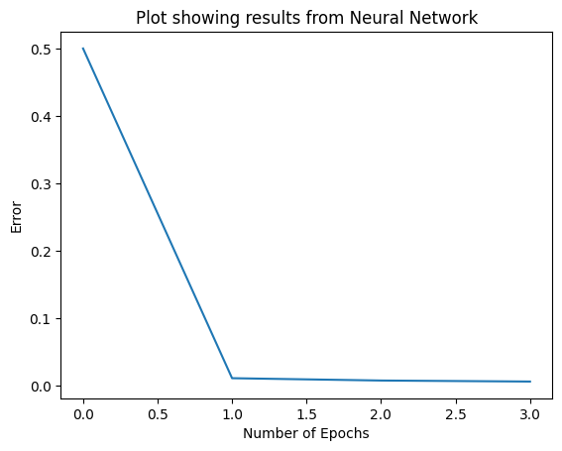
Doing these activities helped to understand perceptron better, learn how to implement multi-layer architectures to defeat those limitations and solve complex, non-linear problems. In neural networks, they stressed the importance of weight adjustment, activation functions and learning rates.

